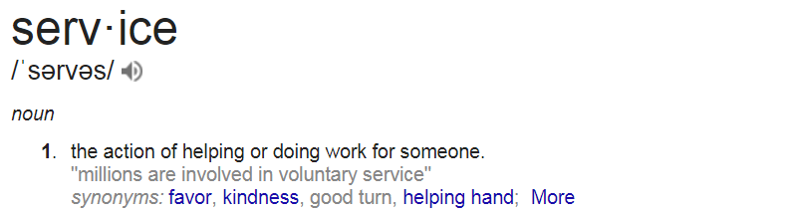
At BHOSPITALITY, our mission is to exceed service expectations at all levels of our business. Is YOUR mission the same? If so, we’re looking for folks just like you to share your passion and enthusiasm for service with the world…or maybe just the tri-cities area to start.
Our ever-growing team requires the services of a
Restaurant Server
What you will be doing:
Your goal should be simple too...exceed expectations in all you do! We are looking for people who wants to make a difference and are genuinely interested in people. You would be invested in creating memorable experiences for our Guests at The Bruce Restaurant and Bar, be a real foodie and enjoy working with amazing people too. If this sounds like something you can handle, email us or come in to see us.
What we’re looking for:
Service professionals - In this role, providing warm, welcoming and amazing service to our guests has to be your thing. And you need to look the part too!
Extroverts - You’ve gotta love talking to people and being in the middle of it all.
Communication all stars – Perhaps you are a mind reader, but we sure aren’t. You’ll need to communicate early and often so we can work together to be our best selves.
Super human strength – Just kidding, but you do need to be comfortable with setting up events which includes lifting up to 25 lbs and moving tables and chairs.
Access to Transportation –This is extremely helpful to get you to where you’re going.
Smart Serve Certified – If you don’t have it, that’s okay you just need to be prepared to go and get it.

Why you want to work here:
- You love the flexibility of working a variety of different shifts including weekends, mornings, evenings and weekends.
- A job well done will be noticed (you’re not a small cog in a big wheel here!)
- It’s been your dream to work with an ever-growing, changing business and you crave delivering excellence.
- You are looking for an outlet for your confidence, enthusiasm and drive.

Job Type: Full-time

