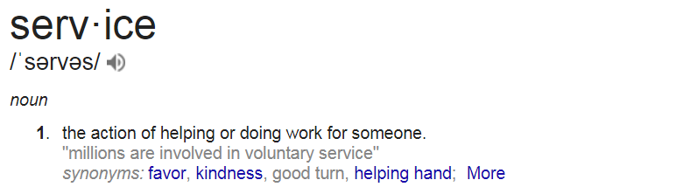
Organically grown from the demand for specialized and unique catering from the Cambridge Hotel and Conference Centre, BHOSPITALITY has been serving the tri-cities area since 2017 and is newly awarded New Venture of the year 2017 by Cambridge Chamber of Commerce Business Excellence Awards.
• Are you someone who enjoys cooking quality local food?
• Do you enjoy working with a positive and ambitious team?
• Do you need an outlet for your passion and creativity?
Our mission is to exceed service expectations at all levels of our business; is YOUR mission the same? If so, we’re looking for folks just like you to share your passion and enthusiasm for service with the world…or maybe just the tri-cities area to start.
Our ever-growing team requires the services of a Full time Chef de Partie
We are looking for someone who wants to make a difference in their guests lives; are you interested and passionate about being mentored and working with leaders who take time to research, learn, grow and develop you? Are you someone who enjoys serving quality local food, great colleagues, and an awesome work environment? If this sounds like something you can handle, email us or come in to see us.
Job Overview:
This is an ideal position for a Chef de Partie who is open to working in some pretty cool spots. The position is full time and has awesome benefits available. You will want to bring your creativity, make features and deliver dining excellence while be very organized, efficient and different….to us different is so good!
• Are you a communicator and are you interested and passionate about mentoring and developing your team to excellence?
• Are you someone who enjoys cooking good quality local food, great colleagues, and an

awesome work environment?
• Do you have a flare for being diligent and accountable?
Superstar Status:
- Be experienced in areas of various cooking methods, ingredients, equipment operation and culinary terminology
- Be accurate, consistent and organize
- Be committed to cleanliness and making effective impact
- 5-8 years in the field with some supervisory experience
Be striving to create nothing but pure awesomeness and just Be You!!

Job Type: Full-time

