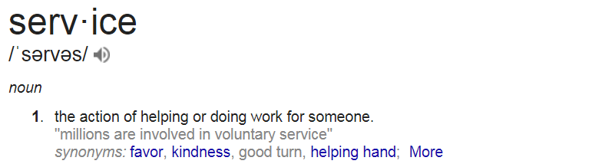
Organically grown from the demand for specialized and unique catering from the Cambridge Hotel and Conference Centre, BHOSPITALITY has been serving the tri-cities area since 2017 and is newly awarded New Venture of the year 2017 by Cambridge Chamber of Commerce Business Excellence Awards.

Are you someone who enjoys serving local food?
Do you enjoy working with a positive and ambitious team?
Do you need an outlet for your passion and creativity?
Our mission is to exceed service expectations at all levels of our business; is YOUR mission the same? If so, we’re looking for folks just like you to share your passion and enthusiasm for service with the world…or maybe just the tri-cities area to start.

Our ever-growing team requires the services of a Banquet Manager.
We are looking for someone who wants to make a difference in their guests lives. Are you interested and passionate about being mentored and working with leaders who take time to research, learn, grow and develop you? Are you someone who enjoys serving quality local food, great colleagues, and an awesome work environment? If this sounds like something you can handle, email us or come in to see us.
Job Overview:
This is an ideal position for a Banquet Manager who is open to working in some pretty cool spots. The position is full time and has awesome benefits available. You will learn from the best which will inspire you to create and make features and deliver dining excellence while be very organized, efficient and different….to us different is so good!

Superstar Status:

· Be experienced in areas of various serving methods
· Be accurate, consistent and organized
· Be committed to cleanliness and making effective impact
· Be striving to create nothing but pure awesomeness and just Be You!!
Why you want to work here:

A job well done will be noticed (you’re not a small cog in a big wheel here!)
It’s been your dream to work with an ever-growing, changing business and you crave delivering excellence.
You are looking for an outlet for your confidence, enthusiasm and drive.

Job Type: Full-time

